Adverbs of Degree

🔹 What Are Adverbs of Degree?
# Source: AI Source: Provided by: [Data Path: Persons Table -> ID Column: 1, Name_En Column: Motasem Essam] -> From: [Chatgpt (GPT-4-turbo)] on [7/27/2025]
Adverbs of degree tell us to what extent, how much, or how little something happens or is true.
They modify verbs, adjectives, or other adverbs, and answer the question: 👉 "How much?" or "To what degree?"

✅ Common Adverbs of Degree
# Source: AI Source: Provided by: [Data Path: Persons Table -> ID Column: 1, Name_En Column: Motasem Essam] -> From: [Chatgpt (GPT-4-turbo)] on [7/27/2025]
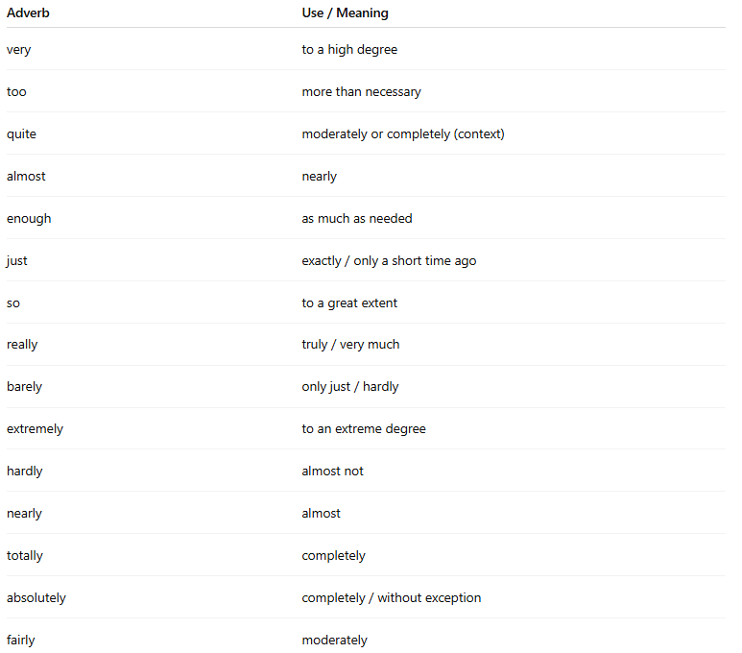
Adverb | Use / Meaning
very | to a high degree
too | more than necessary
quite | moderately or completely (context)
almost | nearly
enough | as much as needed
just | exactly / only a short time ago
so | to a great extent
really | truly / very much
barely | only just / hardly
extremely | to an extreme degree
hardly | almost not
nearly | almost
totally | completely
absolutely | completely / without exception
fairly | moderately

📚 Examples in Sentences
# Source: AI Source: Provided by: [Data Path: Persons Table -> ID Column: 1, Name_En Column: Motasem Essam] -> From: [Chatgpt (GPT-4-turbo)] on [7/27/2025]
- She is very tired.
- He speaks English quite well.
- I'm almost done.
- This box is too heavy to lift.
- We didn’t run fast enough.
- He just arrived.
- They were completely silent.

🧠 Key Notes
# Source: AI Source: Provided by: [Data Path: Persons Table -> ID Column: 1, Name_En Column: Motasem Essam] -> From: [Chatgpt (GPT-4-turbo)] on [7/27/2025]
- Modify adjectives:
✅ The movie was really interesting.
- Modify verbs:
✅ I almost forgot your birthday.
- Modify other adverbs:
✅ She runs very quickly.
- Be careful with "too":
❌ He is too friendly. (might suggest it’s a problem)

Adverbs of Degree vs Adverbs of Frequency
# Source: AI Source: Provided by: [Data Path: Persons Table -> ID Column: 1, Name_En Column: Motasem Essam] -> From: [Chatgpt (GPT-4-turbo)] on [7/27/2025]
These two types of adverbs serve different functions in a sentence. Here's a clear comparison:

✅ Comparison Table
# Source: AI Source: Provided by: [Data Path: Persons Table -> ID Column: 1, Name_En Column: Motasem Essam] -> From: [Chatgpt (GPT-4-turbo)] on [7/27/2025]
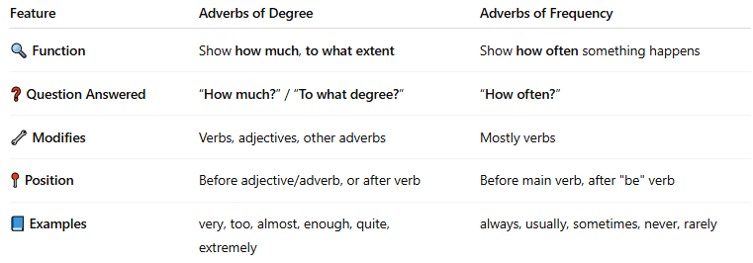
Feature | Adverbs of Degree | Adverbs of Frequency
🔍 Function | Show how much, to what extent | Show how often something happens
❓ Question Answered | “How much?” / “To what degree?” | “How often?”
🔧 Modifies | Verbs, adjectives, other adverbs | Mostly verbs
📍 Position | Before adjective/adverb, or after verb | Before main verb, after "be" verb
📘 Examples | very, too, almost, enough, quite, extremely | always, usually, sometimes, never, rarely

🧪 Examples in Sentences

Adverbs of Degree
# Source: AI Source: Provided by: [Data Path: Persons Table -> ID Column: 1, Name_En Column: Motasem Essam] -> From: [Chatgpt (GPT-4-turbo)] on [7/27/2025]
- She is very smart.
- The water is too cold.
- I almost finished.
- That’s just enough.

Adverbs of Frequency
# Source: AI Source: Provided by: [Data Path: Persons Table -> ID Column: 1, Name_En Column: Motasem Essam] -> From: [Chatgpt (GPT-4-turbo)] on [7/27/2025]
- He always arrives early.
- They never eat meat.
- I often read before bed.
- We sometimes walk to school.

🧠 Key Difference in Use
# Source: AI Source: Provided by: [Data Path: Persons Table -> ID Column: 1, Name_En Column: Motasem Essam] -> From: [Chatgpt (GPT-4-turbo)] on [7/27/2025]
- Degree = Intensity / Amount
“She is so tired.” → how tired?
- Frequency = Repetition / Occurrence
“She often sleeps early.” → how often?

